
PROFESSIONAL DEVELOPMENT 4

Test 2

Name: Moipone
Surname: Kabai
Student number: 215203569
Stream: AppDev

Due date: 22 July 2020
Question 1
  - PV1 = FV/(1+i)^n
= 34 000/ (1+0.1) ^1
= 34 000/1.1
= R30 909.09
PV2 = FV/ (1+i) ^n
= 34 000/ (1+0.1) ^2
= 34 000/1.21
= R28 099.17
PV3 = FV/ (1+i) ^n
= 34 000/ (1+0.1) ^3
= 34 000/1.331
= R25 544.70
PV4 = FV/ (1+i) ^n
= 34 000/ (1+0.1) ^4
= 34 000/1.4641
= R23 222.46
PV5 = FV/ (1+i) ^n
= 34 000/ (1+0.1) ^5
= 34 000/1.61051
= R21 111.32
Therefore the Net Present Value (NPV) = R128 886.74
  - Payback Period = Project cost / Annual Cash Flow
= 120 000 / 34 000
= 3.5 (3years 5months)

  - IRR = If NPV = 0 or close to zero
Calculations shows that:
If IRR is 18% NPV = R6673.03
If IRR is 18.5% NPV = R2609.18
If IRR is 18.75% NPV = R597.75
If IRR is 18.80% NPV = R197.09
If IRR is 18.85% NPV = -R203.03
Therefore, IRR is between 18.82% and 18.83%
Question 2
  - No explicit rationale capture: means that resources are spent only on development. The documentation focuses only on system models. Rationale information is present only in the developers’ memories and in communication records such as email messages, memos and faxes.
Rationale reconstruction: means resources are spent in recovering design rationale during the documentation effort. The design criteria and motivation behind major architectural decisions is integrated with the corresponding system models. Discarded alternatives and argumentation are not captured explicitly.
Rationale capture: is when major effort is spent in capturing rationale as decisions are made. Rationale information is documented as a separate model and cross-referenced with other models. The rationale behind the requirements model can then be captured by attaching issue models to user cases.
Rationale integration: is when the rational model becomes the central model that developers use. Rationale produced during different phases are integrated into a live and searchable information base. Changes to the system occur first in the information base as a discussion followed by one or more decisions. The system models represent the sum of the decisions captured in the information base.

  - The purpose of Rationale Management is the justification of decisions. Rationale models represent the reasoning that leads to the system, including its functionality and its implementation. It is critical in two areas namely: support of the decision making and the support in capture of knowledge. This would help the success of the project by making assumptions about the relative risks present in the development process. The development is more likely to start the tasks that are related to a recently released component as opposed to a mature one. Capturing the justifications behind the risks and fallback plans facilitates mitigation if these risks become problems.
  - The information to be captured to facilitate information is as follows:
Issue - To each decision corresponds an issue to be solved so that development can proceed. An important part of the rationale is a description of the specific issue being solved.
Alternatives - Possible solutions that could address the issue under consideration. These include alternatives that were explored but discarded because they did not satisfy one or more criteria.
Criteria - Desirable qualities that the selected solution should satisfy such as usability, number of input errors per day.
Argumentation - Software development decisions are not algorithmic because developers discover issues, try solutions and argue their relative benefits.
Decisions - A decision is the resolution of an issue representing the selected alternative according to the criteria that were used for evaluation and the justification of the selection.
Question 3
  - Configuration management is the discipline of managing and controlling change in the evolution of software systems. It is the process of controlling and monitoring change to work products. Once a baseline is defined, configuration management minimizes the risks associated with changes by defining a formal approval and tracking process for changes. Its systems automate the identification of versions, their storage and retrieval, and supports status accounting.

  - The following are the workings of a suitable tool for software configuration:
    - The development should be done with as few code lines as possible. This falls under one of the main values of SCM which is to root out redundancy and integration issues.
    - Test early and often because testing is important to good software configuration management. Each pattern represents an opportunity for testing before code is released to the next pattern in the hierarchy.
    - Integrate early and often, private workspaces are critical because they allow developers to test integration before actually integrating with the main line.
    - Use tools to automate testing, build, and integration. There are dozens of tools that help teams automate critical aspects of the development process.
  - Software configuration management is one of the primary concerns during system implementation and maintenance, which its basic approach is to create a software repository, usually on a network drive or online, and then to keep a working copy of the software on a local hard drive. This basic approach supports multiple developers, assuming that they all have access to the repository, but is useful even for a single developer because the repository maintains a history of all software that was checked in.
Question 4
  - The difference between the two is that in a waterfall software development lifecycle the phases are linked to each other such that each phase must be completed before the next phase can begin, which is time consuming. The system must therefore evolve to remain useful, which requires rolling back to make changes in a phase we see fit. Failure to this will result in the system not being what the user wants. When program and design errors emerge, the need for new functionality will be identified, which requires all the phases to be restarted to fit the new requirements. Because the software process is not a simple linear model but involves feedback from one phase to another, document produced in each phase may then have to be modified to reflect the changes made. In order for the Waterfall Model to be perfect and fit customer needs, it has to be planned out for a very long period of time to meet all the requirements. So the planning phase might even take up to a year to make sure that every aspect has been covered so that there won’t be a need to rollback to previous phases. On the other hand, the Unified Process model is an iterative, incremental, architecture-centric, and use-case driven approach for developing software. This model consists of four phases, including: Inception, in which you collect requirements from the customer and analyze the project's feasibility, its cost, risks, and profits. Unlike the waterfall model, phases of the development process are not associated with specific workflows, meaning that all phases could be deployed at the same time, no need to wait for completing one phase before the start of the other one. They could basically even go on at the same time.
  - For this software system intended to support the functions of a municipal council, I would use the Spiral Model. In a Spiral Model, there are loops, which are spilt into 4 sectors namely, objective setting, risk assessment and reduction, development and validation, then planning. This model is based on the same activities as the waterfall model, but adds risk management, reuse and prototyping to each activity. The model focuses on addressing risks incrementally, in order of priority. In an objective setting, specific objectives for the municipal council will be defined. Constraints on the process and the product will be identified and a detailed management plan of the system is drawn up. Project risks are identified. Alternative strategies, depending on these risks, may be planned. In risk assessment and reduction, for each of the identified project risks, a detailed analysis is carried out. Steps are taken to reduce the risk. For example, if there is a risk that the requirements for deeds management are inappropriate, a prototype system may be developed to counteract to the risk. In development and validation, after risks have been evaluated, a development model for the system is chosen. For example, throwaway prototyping may be the best development approach if user interface functionality related to deeds management, driver and vehicle licensing, zoning of districts, electricity distribution and payments among other function risks are dominant. In the last sector, planning, the project is reviewed and a decision made whether to continue with a further loop of the spiral. If it is decided to continue, plans are drawn up for the next phase of the project. This will be the best model to use because of its explicit recognition of risk, and I need to have a plan for as many risks I might encounter for this software system as possible.

Question 5
  - 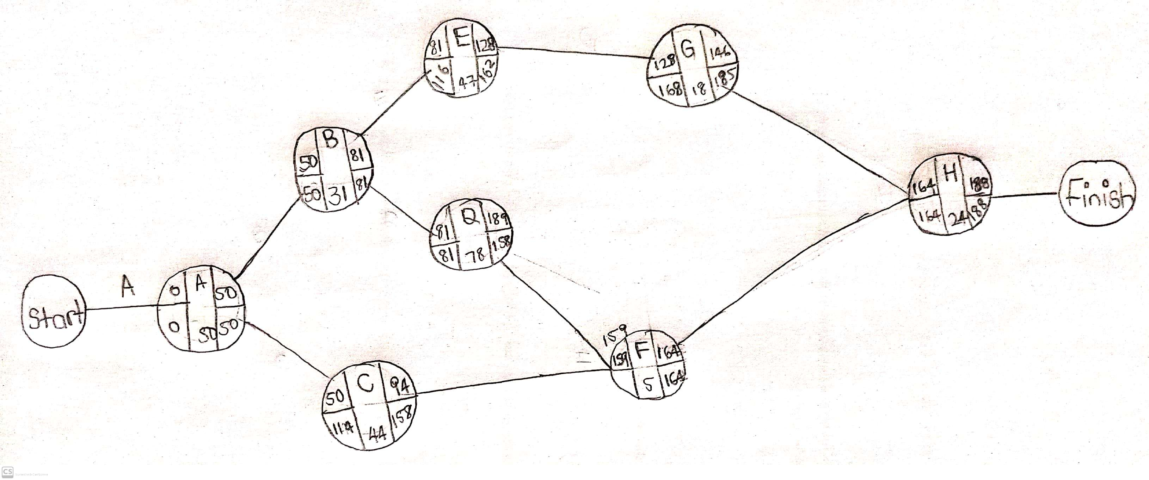
  - ED = $\left(MOT + \left(4 * MLT\right)+ MPT\right)/6$
= (20 + (4 * 24) + 25) / 6
= (20 + 96 + 25) /6
=141/6
=23.5
=24 days
  - P (Z) = 0.95
P (Z=X) = 2.325
Z = X - µ/s = 2.325
X – 188 = 12.76425
X = 12.76425 + 188
X = 200.77 days
  - X = zs +µ
= 0.95(1.95) + 188
=1.8525 + 188
=189.85
Z = (x - µ) / s
= (189.85-188) / 1.95
= 0.95

